Project 1.2.11a Glider Design Challenge Report

Student Name: ____Jaehwa Hong______________
In Project 1.2.10 Glider Design Challenge One, you designed a stable glider. In this project, you are going to expand your knowledge through more advanced skills while refining your glider design. This is an importance design step of refining and testing a design to improve your design concept.

Glider Design
Describe the information that you entered into the AERY software.

I had to change the length of the components of glider. At the main tab, I could change the location of the wing, stabilizer, and vertical stabilizer to create the stable glider. Next tab, Wing, I could change velocity and wing span that this program always wanted me to change. Other tabs could change the measurement horizontal and vertical stabilizer which allowed to adjust the center of gravity.

Benefits of Computer Based Models
Describe the information that the AERY software provides. Describe how you would compute the same information using your knowledge of Aerospace engineering and a calculator.

The information that the AERY provides the general information about your entire glider. Also, it provides statistics and exact measurement of the glider if it were to build with this design.
Glider Construction
Based on what you have learned, describe additional skills and knowledge essential for transforming a glider design into an actual model.

From the two glider challenge, I learned that it is hard to design the best glider which indicated as AERY evaluation number. When I was designing the glider for challenge 2, I originally had 194 and it was hard. But when I changed the size of the glider, It was easier to design the glider that would fly with AERY evaluation number of 155. And, I learned the importance of vertical tail. It was extremely important to balance the glider with nose mass.

Glider Design Prints
Attach AERY glider design software prints from the two challenges.

Challenge 1
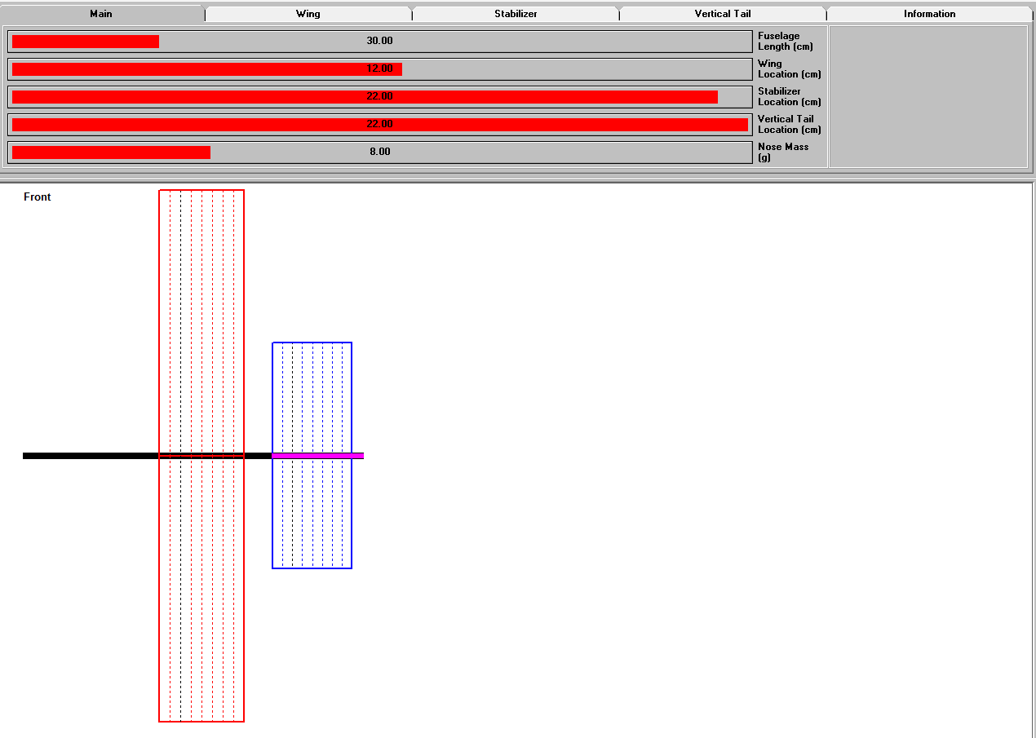
Challenge 2
